

**Environments Dashboard**

**User Guide**

September 7th, 2018

# Summary

This document contains information about the website that makes Start and Stop of Azure hosted Virtual Machines.

# Revision History

|  |  |  |  |
| --- | --- | --- | --- |
| **Date** | **Author** | **Version** | **Change reference** |
| 9/7/2018 | Valery Moskalenko | 1.0 | Initial version |
| 1/18/2019 | Valery Moskalenko | 1.1 | Minor fix. Updated the picture with Filtering |

**Table of Contents**

Summary 2

Revision History 2

1. The first run 3

2. Loading 3

2.1 Error messages 4

2.1.1 Table loading error 4

2.1.2 Row loading error or VM State loading error 4

3. VM Information 5

3.1 Details 6

4. Start and Stop VM 7

4.1 Logs 7

4.2 Unknown button 7

4.3 Refresh the status 8

5. Filtering and Sorting 8

# The first run

On the first run, please enter your name and click the Set button. Your name will be used later to show other users who start and stop selected VM.

If you see folded “Information about you” panel, then system saved your name. If you would like to show Information panel, then click on the Information panel header to unfold it.

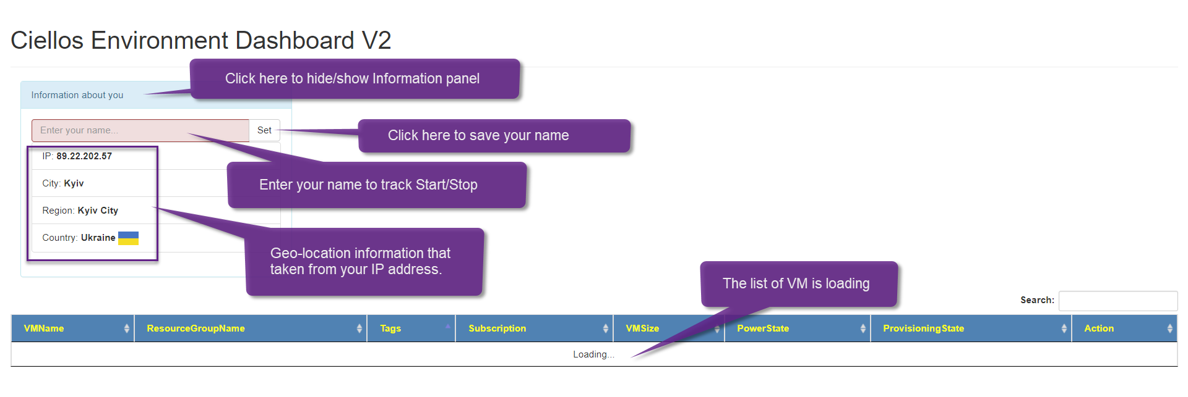

# Loading

The sequence of loading is the following

1. HTTP server sends index.html and your browser render it.
2. Table script loads the list of VM from all subscriptions. At this stage, you should see “Loading…” message  
   
3. For each VM starts a bunch of async requests to show the current State of VM.   
   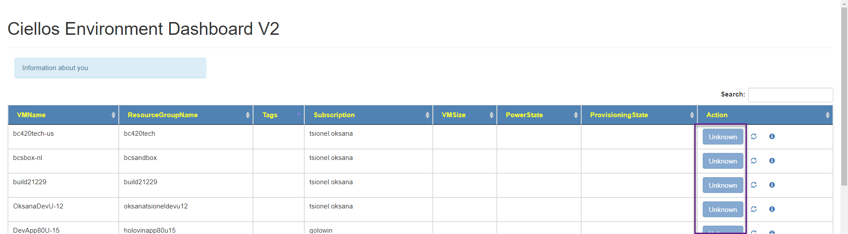
4. After a while, you should see the current VM status  
   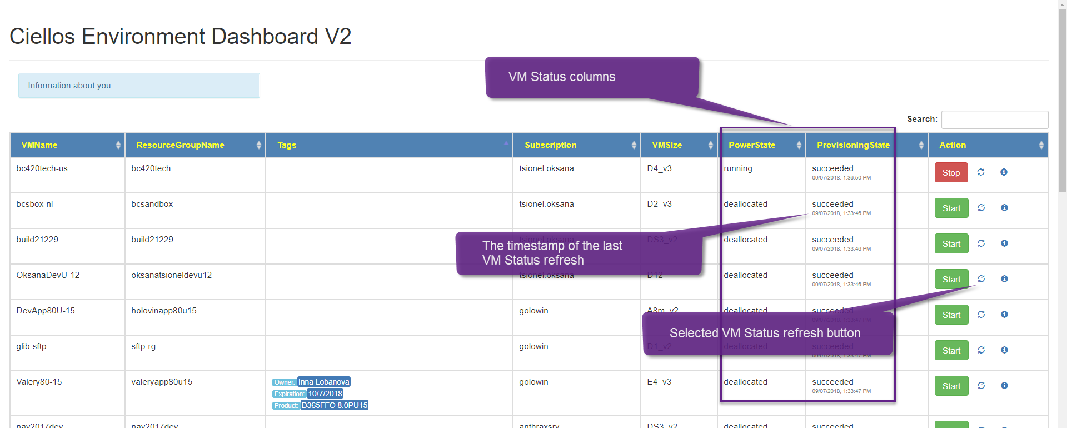

## Error messages

### Table loading error

If you see ERROR text instead of the list of VMs, please click the refresh button on your browser or press F5 to do the same.

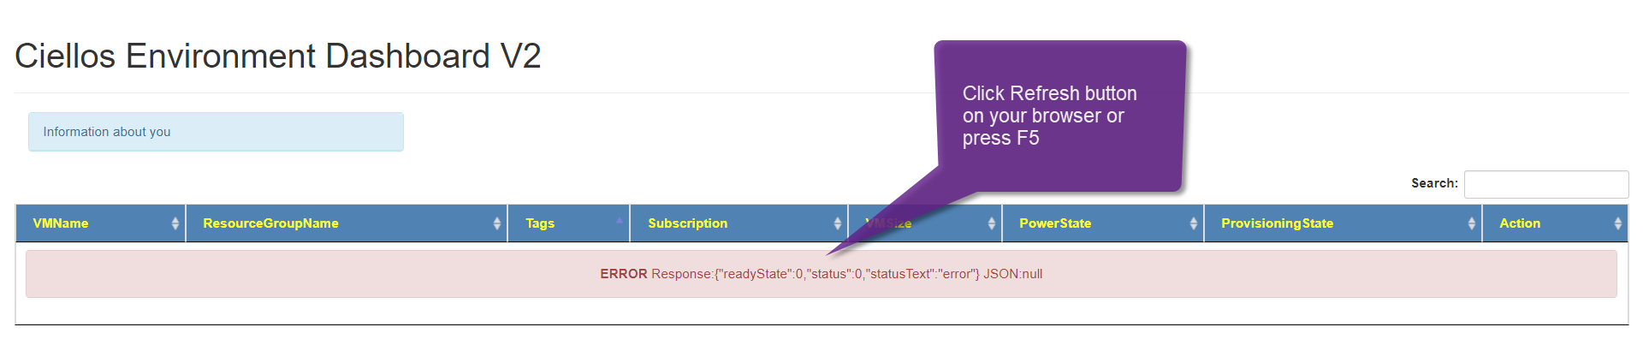

### Row loading error or VM State loading error

If you see for 1-second red background animated highlight on the table row, that means error loading Azure VM State. Please click on refresh button.



# VM Information

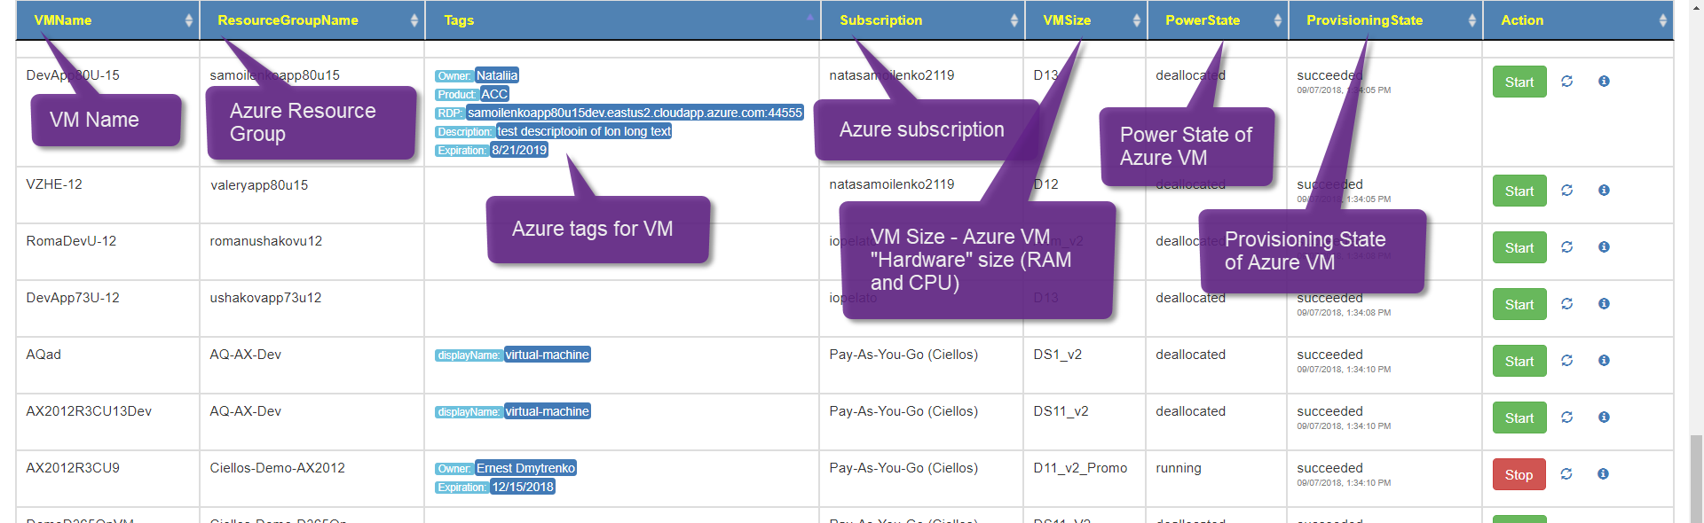For each VM you may find the following information from the table columns

* VM Name
  + Azure VM Name
* Resource Group Name
  + Azure Resource Group Name
  + When you deploy VM from LCS this is your LCS Environment name
* Tags
  + Azure tags for VM
  + **Owner** and **Expiration** date should be mandatory tags
    - When the **expiration** date is come we will ask the **owner** about this VM.
  + We support the following tags
    - **RDP** – Remote desktop connection string
    - **Description**
    - **Project** – Project name
    - **Product** – subproject name, like ACC, ICM or BU
  + We are open adding new tags
* Subscription
  + Azure subscription name
* VM Size
  + Azure VM “Hardware” specification
  + Typically, we are using the following VM sizes
    - D2 – 2 CPU, 8Gb RAM, $154/month
    - D4 – 4 CPU, 16GB RAM, $308/month
    - D8 – 8 CPU, 32Gb RAM, $616/month
    - D16 – 16 CPU, 64Gb RAM, $1233/month
    - E2 v3 – 2 CPU, 16Gb RAM, $177/month
    - E4 v3 – 4 CPU, 32Gb RAM, $354/month
    - E8 v3 – 8 CPU, 64Gb RAM, $709/month
    - D11 v2 – 2 CPU, 14Gb RAM, $177/month
    - D12 v2 – 4 CPU, 28Gb RAM, $354/month
    - D13 v2 – 8 CPU, 56Gb RAM, $709/month
    - D14 v2 – 16 CPU, 112Gb RAM, $1419/month
    - A1 v2 – 1 CPU, 2Gb RAM, $47/month
    - B1S – 1 CPU, 1Gb RAM, $13/month
    - B2S – 2 CPU, 4Gb RAM, $52/month
    - B1MS – 1 CPU, 2Gb RAM, $21/month
      * All prices are subject to change. Please use the following link to get current prices <https://azure.microsoft.com/en-us/pricing/details/virtual-machines/windows/>
      * ‘S’ means that Premium (SSD) drives enabled
      * ‘Promo’ means lower cost (or the same price) for the same VM Size
* Power State
  + Azure VM Power State
  + Please find a full list of states here <https://docs.microsoft.com/en-us/dotnet/api/microsoft.azure.management.compute.fluent.powerstate?view=azure-dotnet>
* Provisioning State
  + Azure VM deployment status text
  + Please find details here <https://docs.microsoft.com/en-us/azure/virtual-machines/windows/error-messages>

## Details

Click on theicon to see details about selected VM.

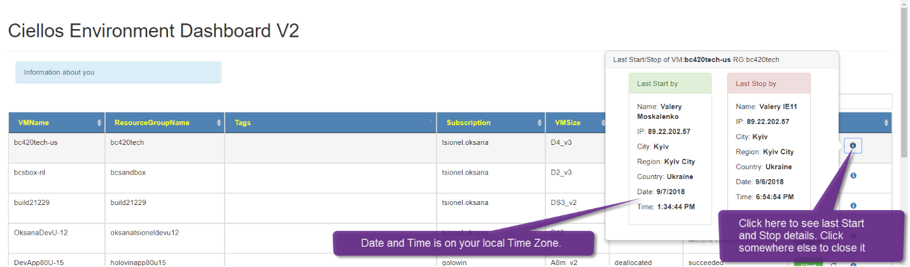

On details, you may see the information regarding who last time start and stop selected VM. This information saved every time when somebody clicks on Start or Stop button on this website.

If somebody starts and stops VM from another website, i.e. portal.azure.com, then you may see here incorrect information.

# Start and Stop VM

To start VM, click on the Start button. To stop VM, click on the Stop button.

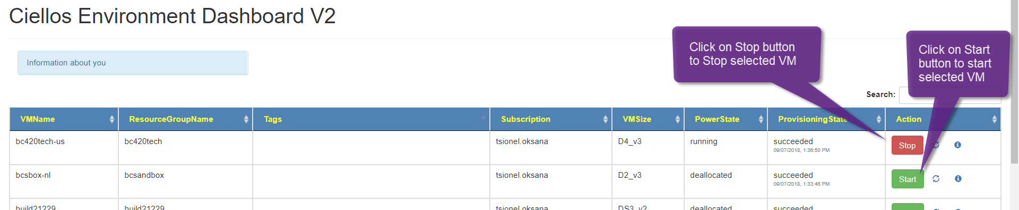

Starting or stopping the virtual machine may take several minutes. After the start or stop is complete, the status of the virtual machine will be refreshed automatically.

However, you can refresh the status of the virtual machine at any time.

## Logs

On the bottom, you may find the Start/Stop logs

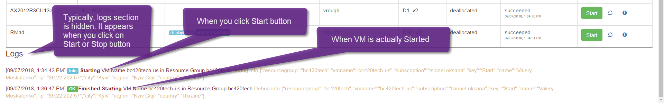

## Unknown button

When you see the Unknown button, then you can’t click on it. Unknown means that the current VM state cannot be Started or Stopped. Or there is error happening on getting status. 

Please click on the refresh button to refresh the VM state.

## Refresh the status

Please click on the refresh button to refresh the VM state. After refresh is complete, the timestamp will be updated.

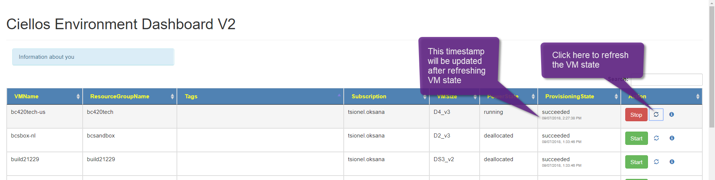

# Filtering and Sorting

Type in Search to filter table rows.

Click on columns to sort table rows by this column. Click again to change the sorting order.

